Autumn One
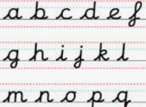
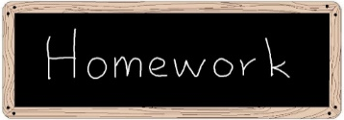
 | Reading –  5 times a week  (Please ensure their reading books are brought in on a daily basis)
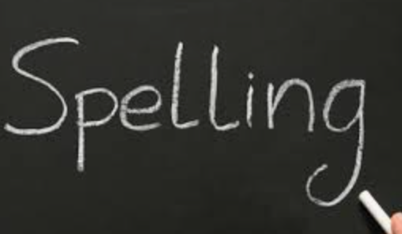 | Spellings  Spellings are available on Dojo and the school website.  Children will have a spelling test each Friday.
 | Times table practice x2 and related division facts  Challenges will be set on the Emile App for children to complete this will be linked to our English and Maths topics.
 | Handwriting Practise

Mission and Values Challenges

Respect:
Matthew 7:12 “So whatever you wish that others would do to you, do also to them, for this is the Law and the Prophets.”
Draw a picture of someone you respect and explain why. | Healthy Lifestyles  Create a poster about keeping healthy and how to look after yourselves.
Write down ten ways that you’re special and unique. | In RE we are looking at Creation and Covenant. We will be studying the Creation story and the story of Noah. Why not complete some artwork to illustrate the favourite parts of the story.

