Pupil Premium Strategy
This statement details our school’s use of pupil premium funding to help improve the attainment of our disadvantaged pupils.
It outlines our pupil premium strategy, how we intend to spend the funding in this academic year and the effect that last year’s spending of pupil premium had within St Mary Magdalene’s.
School Overview
Detail | Data
School Name | St Mary Magdalene’s RC Primary School
Number of pupils in school | 195 – Sept 2024  192 – Sept 2025
Proportion (%) of Pupil Premium eligible pupils | 24 - 39 children (20%)  25 – 40 children (21%)
Academic years/years that our current pupil premium strategy plan covers (Recommendation of three years) | 24 – 25  25 – 26  26 – 27
Date the statement is published | September 2025
Date on which it will be renewed | July 2025
Statement authorised by
Pupil Premium Lead | Keeley Robinsworth
Governor/Trustee lead

Funding Overview
Detail | Amount
Pupil premium funding allocation this academic year | 24 - £56,240  25 - £56055
Recovery premium funding allocation this academic year | 2024 was the first year this has not been allocated
Pupil premium funding carried forward from previous years (enter £0 if not applicable) | £0
Total budget for this academic year  If your school is an academy in a trust that pools this funding, state the amount available to your school this academic year | 24 - £56,240  £59853.34  (Final figures)  25 - £56055

Pupil Premium Strategy Plan
Our intention is that all pupils, irrespective of their background or the challenges they face, make good progress and achieve high attainment across all subject areas. The focus of our pupil premium strategy is to support disadvantaged pupils to achieve that goal, including progress for those who are already high attainers.
We will consider the challenges faced by our vulnerable pupils, such as those who have a social worker and young carers. The activity we have outlined in this statement is also intended to support their needs, regardless of whether they are disadvantaged or not.
High-quality teaching is at the heart of our approach, with a focus on areas in which disadvantaged pupils require the most support. This is proven to have the greatest impact on closing the disadvantage attainment gap and at the same time will benefit the non-disadvantaged pupils in our school. Implicit in the intended outcomes detailed below, is the intention that non-disadvantaged pupils’ attainment will be sustained and improved alongside progress for their disadvantaged peers.
Our approach will be responsive to common challenges and individual needs, rooted in robust diagnostic assessment, not assumptions about the impact of disadvantage. The approaches we have adopted complement each other to help pupils excel. To ensure they are effective we will:
- ensure disadvantaged pupils are challenged in the work that they’re set
- act early to intervene at the point need is identified
- adopt a whole school approach in which all staff take responsibility for disadvantaged pupils’ outcomes and raise expectations of what they can achieve

Challenges
This details the key challenges to achievement and success that we have identified among our disadvantaged pupils.

Challenge Number | Detail of challenge
1 | Children’s missed learning due to absences and lates over their time at school  (These can often be sporadic days)
2 | Children’s love of books – Reading for pleasure, vocabulary, imagination, lack of resources
3 | Resilience and stamina for learning.  Children’s concentration span
4 | Behaviour for learning  When children come into school, some are not ready for the day’s learning.
5 | Lack of opportunities and experiences in the wider word.
Intended Outcomes
Intended Outcome | Progress  (Reviews Sept 25)
Children’s attainment in reading and phonics will improve amongst the disadvantaged children with accelerated progress seen to close the gaps. | Children’s attainment in reading continues to be below whole school however they make good progress and nearly 20% are making accelerated progress which is higher than previous years in order to continue to close the gaps.  Attainment  Progress:  Phonics:  EYFS – 20% children on track for phonics  Y1 – 50% passed their PSC  Y2 – 40% passed their PSC in the first or second year.  Phonics continues to be a focus and is showing the increase in disadvantaged children closing the gaps and accomplishing the PSC.
Children’s Speech and Language will improve which will have a positive impact on the attainment of writing amongst the disadvantaged children with accelerated progress seen to close the gaps. | As a school, we are embedding Speech and Language across school. We have invested in a program called WELCOM which was trialled in 2024 but will be embedded with all EYFS children from September 2025. The writing impact is not clear as yet as we changed the writing curriculum this year which has also had an impact. Therefore in the 25/26 year this should present us with a clearer positive image.
Children’s attainment in number and fluency in maths will improve amongst the disadvantaged children with accelerated progress seen to close the gaps. | Maths data and arithmetic has been positive, as school put an ownership on daily times tables, number and arithmetic. From the summer data you can see that nearly 50% pupils are on track, exceeding or just below. The progress is children have made is also positive with 5 PP children making accelerated progress.  Maths Attainment:  Maths Progress:
To gain a broader outlook on our community and the wider world around us. | As a school we completed the ‘Building Bridges’ project across school. This has had a positive impact on the children identifying the links between religions and has had positive feedback from the staff. As a school, we feel there is still work to do about building children’s knowledge about the local and wider world issues.
To achieve and sustain improved wellbeing for all pupils in our school, particularly our disadvantaged pupils. | Children’s wellbeing is always at the forefront of our mind and this was clear in the amount of referrals we made last year for further support from School nurse, Early Help etc.  Beyond academic challenges, we want to assure you that the holistic well-being of our pupils remains paramount. We maintain an established and highly valued partnership with Caritas, whose trained social worker provides unique, tailored support for children who may be struggling. This service has been positively received and demonstrates our deep commitment to nurturing every child’s emotional and social development alongside their academic growth.

Activities in this academic year (2025-2026)
This details how we intend to spend our pupil premium academic year to address the challenges listed above.

Teaching (for example CPD, recruitment and retention)
Approx budget cost: £10,000
Activity | Evidence that supports this approach | Challenge Numbers
CPD for all staff on developing a whole school curriculum to ensure our curriculum meets the needs of all learners. | Pupils receive a knowledge rich curriculum which is sequenced and focused to ensure progression of learning and skills across year groups is evident. https://educationendowmentfoundation.org.uk/news/eefblog-what-do-we-mean-by-knowledge-rich-anyway  The school has bought into the Kapow online schemes of learning to develop Geography, History, Science, Art and Design Technology.  Red Rose maths is now a scheme used across school in maths and is being implemented in Year 6 this year, ensuring small steps of progression in the teaching and learning of maths. This is in addition to a focus on arithmetic and number.  ELS Phonics purchased and we will continue with CPD for all staff. | 1, 2, 3, 4, 5
Use of Insight tracker to identify gaps across the curriculum and provide CPD for staff to work closely with the children to close them | Teachers to have CPD on the use of insight and how to analyse the data.  Subject leaders to upload outcomes onto insight to help break down and identify the areas that children have gaps. Interventions and CPD put in place to support this.  “If I had to reduce all of the research on feedback into one simple overarching idea… it would be this: feedback should cause thinking” (Wiliam, 2011, 126). It requires ‘mindfulness’ – time spent thinking (really thinking) about the task (111-112), it should provide a ‘recipe for future action’ https://improvingteaching. co.uk/2013/08/17/closing-the-gap-marking/ | 1, 2, 3
Pupils with POPs to receive targeted intervention based upon needs – this includes any S&L needs. | Pupils with Special Educational Needs and Disability (SEND) have the greatest need for excellent teaching and are entitled to provision that supports achievement at, and enjoyment of, school. https://educationendowmentfoundation.org .uk/education-evidence/ guidancereports/send  Teachers are aware of pupils with POPs. Meetings, reviews and support of the school SENCO, ensures that POPs are completed effectively providing a clear picture of each pupil, their needs, targets and progress. SENCO liaises with outside agencies and reports back to Teachers to provide support which will enable pupil progress. Pupils with POPs will make progress through targeted support. | 1, 3, 4
To implement forest school which will enhance our curriculum enabling children to gain a wider prospective of the world. | Forest School is a philosophy and a way of working in an outdoor environment.  - It is an ethos that promotes self-esteem, creativity, confidence and independence.  - It is a series of long-term sessions that build on the needs and development of the child.  - It enables supported risk-taking, child-centred learning, exploration and play.  - Links across the national curriculum can be made in all subjects to reinforce learning in a creative way.  https://www.marjon.ac.uk/professional-development-for-teachers/better-forest-school/ | 1, 3, 4, 5
Continue to enhance the maths teaching in line with DfE and EEF guidance with the importance of arithmetic and number at the forefront. | Quality teaching of number and math’s delivered via mastery schemes in all classes.  Intervention or development areas for pupils highlighted through mastery approach can then be addressed with teaching assistant, IDL Number, or precision teach intervention.  Continued professional development of teaching staff through clusters and maths hubs, then disseminating examples and methods of good practice to colleagues.  The DfE non-statutory guidance has been produced in conjunction with the National Centre for Excellence in the Teaching of Mathematics, drawing on evidence-based approaches:  Maths_guidance_KS_1_and_2.pdf (publishing.service.gov.uk)  The EEF guidance is based on a range of the best available evidence: | 1, 3, 4
Programs such as Ten:Ten and Picture News | Programs such as these allows us to extend our curriculum for the children. It allows them to have a voice and enables children to read about current events, participate in debates and share their views and opinions.  It develops their vocabulary and understanding of the wider world whilst linking to our Catholic Ethos.  The ten:ten scheme of work focuses on Relationships and Health Education (RHE) in England. The programme includes all pupils and families, and presents the core belief that each of us is created, chosen and loved by God. | 1, 2, 4, 5

Targeted academic support (tutoring, 1:1 support, intervention)
Approx budget cost:

Activity | Evidence that supports this approach | Challenge Numbers
Support children to improve their listening, narrative and vocabulary skills. | Oral language interventions can have a positive impact on pupils’ language skills. Approaches that focus on speaking, listening and a combination of the two show positive impacts on attainment: Booster sessions to be offered to disadvantage pupils  The EEF state ‘Overall, studies of communication and language approaches consistently show positive benefits for young children’s learning, including their spoken language skills, their expressive vocabulary and their early reading skills. On average, children who are involved in communication and language approaches make seven months’ additional progress over the course of a year. All children appear to benefit from such approaches, but some studies show slightly larger effects for children from disadvantaged backgrounds.’ | 1, 2, 3
Use of the new program EMILE for children to complete as homework, intervention and additional support | The Department for Education (DfE) brought together a list of online educational resources to support children’s education at home while they may not be attending their normal education setting.  The DfE “assessed these resources with the support of subject experts to make sure they are: high quality, and appropriate for the students they are aimed at”. The resources were also assessed to ensure they meet a number of technical requirements.  Teach Primary acknowledged ‘MTC with Emile allows teachers to prepare their students for the new Year 4 Multiplication Tables Check (MTC). The interface is identical to the DfE test and so allows pupils to become accustomed to the layout and format. Teachers and pupils can alter the time per question and the times tables involved to build up confidence. Pupils’ progress can be tracked and teachers can accurately forecast results’ | 1, 3, 4
Additional phonics sessions targeted at disadvantaged pupils who require further phonics support across the whole schoool | EEF state ‘ The teaching of phonics should be explicit and systematic to support children in making connections between the sound patterns they hear in words and the way that these words are written.  The teaching of phonics should be matched to children’s current level of skill in terms of their phonemic awareness and their knowledge of letter sounds and patterns (graphemes).  Phonics improves the accuracy of the child’s reading but not necessarily their comprehension. It is important that children are successful in making progress in all aspects of reading including comprehension, the development of vocabulary and spelling, which should also be taught explicit’  Closing the disadvantage gap  Studies in England have shown that pupils eligible for free school meals typically receive similar or slightly greater benefit from phonics interventions and approaches. This is likely to be due to the explicit nature of the instruction and the intensive support provided.  It is possible that some disadvantaged pupils may not develop phonological awareness at the same rate as other pupils, having been exposed to fewer words spoken and books read in the home. Targeted phonics interventions may therefore improve decoding skills more quickly for pupils who have experienced these barriers to learning. | 1, 2, 3

Wider strategies (for example relating to attendance, behaviour and wellbeing of the pupils)
Approx budget cost: £30,000

Activity | Evidence that supports this approach | Challenge Numbers
Specific support for those pupils who struggle to self-regulate. | Positive regard training is to take place for all staff across school to support an understanding of dysregulated pupils and how to support them in school. New strategies put into use to support those pupils. Family and Pupil support worker supports specific families. Continuous reflection and review of practise across school so that the strategies taught through CPD, work for our pupils and families. Pupils feel safe and supported in a learning environment that encourages learning. Pupils use the safe spaces provided without hesitation and personal pupil plans are created to support their daily routine. Sensory circuit created for those pupils who need help to regulate before lessons. Individualised timetables continue to be created for those pupils requiring support. All staff work together to ensure these work effectively.  If we commit to an ethic of care, building relationships and caring for our pupils, aren’t strategies in the name of increasing academic achievement but the actual goal itself.  https://www.cultofpedagogy.com/unconditional-positive-regard/ | 3, 4
Employ a Pastoral Manager to support disadvantaged families both in school and at home to ensure children are ready for learning and have good attendance etc. | Bera research states, ‘Pastoral care in education means a whole-school strategic and operational approach to improve learners’ attendance, and to foster an atmosphere that is conducive for learning and promotes tolerance, resilience, fairness and equal opportunities for all, with due regard for protected characteristics. Such an approach to pastoral care should eliminate racism, inequality, discrimination and other hindrances to learning, to create an ethos that culminates in engagement and academic achievement of learners. Therefore, effective pastoral care can:  - improve students’ attendance and retention rates  - foster an orderly atmosphere in which all students can access opportunities, and enhance their academic achievements  - promote tolerance, especially in students and teachers with due regard for protected characteristics  - subdue racism and inequality  - teach respect for self and others (Benard, 1995, pp. 3–4).’  Teach first state, ‘ professional in a pastoral role can have a profound impact on students. They can be the difference between a child attending school or not, or a family engaging with their child’s education. They can be crucial in ensuring that a child and their family get the intervention and support they need, whether at school or multi-agency level. Essentially, they can be the difference that ensures a child receives an effective education.’ | 3, 4, 5
Nurture breakfast to encourage children to come in on time and ensure they have breakfast and regulated prior to learning. | The EEF acknowledge the importance of breakfast clubs for disadvantaged pupils finding ‘Improvements were seen, it is not just eating breakfast that delivers improvements but attending a breakfast club. This could be due to the content of the breakfast itself or to other social or educational benefits of the club.  Pupil behaviour, as measured by a teacher survey, improved in breakfast club schools. This is interesting because it shows that breakfast clubs may improve outcomes for children who do not even attend breakfast club by improving classroom environments. This key conclusion is unchanged from the original report.’ | 3, 4
Opportunities provided for all pupils to access a variety of sporting activities after school and competition within the Lancashire school’s sports partnership. | The PE subject lead liaises with the Lancashire school’s sports partnership, to ensure that pupils access competitive and enriching sporting activities outside school or within the school day. A variety of sporting clubs are provided after school and arranged by the PE lead in conjunction with TAs and Teachers to meet the needs of all pupils.  Pupils have outdoor learning experiences planned for within the curriculum as well as forest school, making the best use of our outdoor space and provision. Pupil premium pupils experience sporting activities outside the usual school PE curriculum. Pupils are invited to try new sports and develop their competitive skills. Member of staff with PE expertise, delivering PE lessons across school to ensure consistency in teaching, assessment and progression.  Pools to schools organised to ensure all pupils across school access the opportunity to swim. | 1, 3, 4, 5
Attainment (Summer 25 Data)
Whole School
39 Pupils
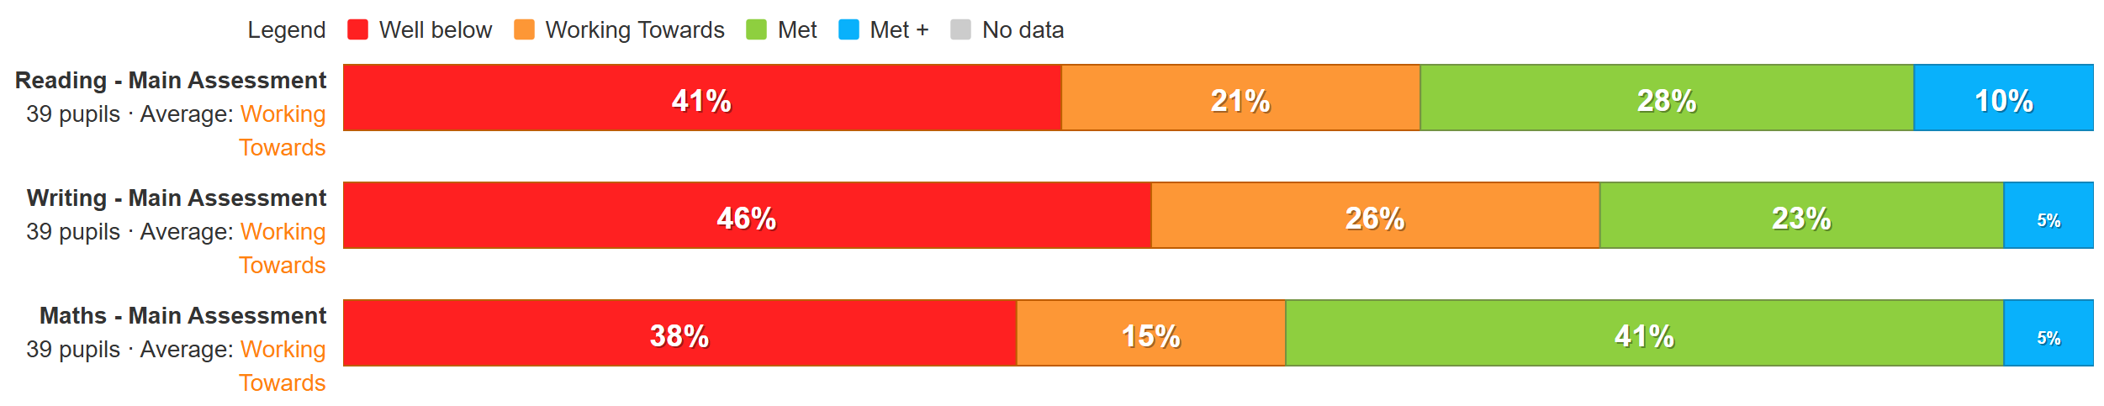
Early Years Attainment
5 Pupils
Met GLD | 40%

Key Stage One Attainment
12 Pupils
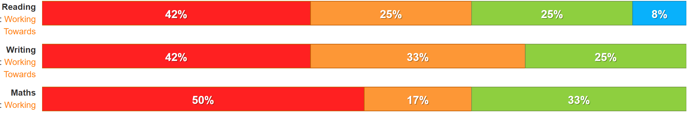

Key Stage Two Attainment
27 pupils
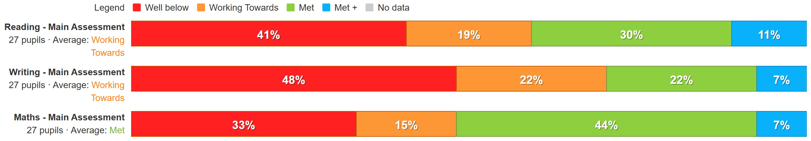

Year 6 Attainment
6 pupils
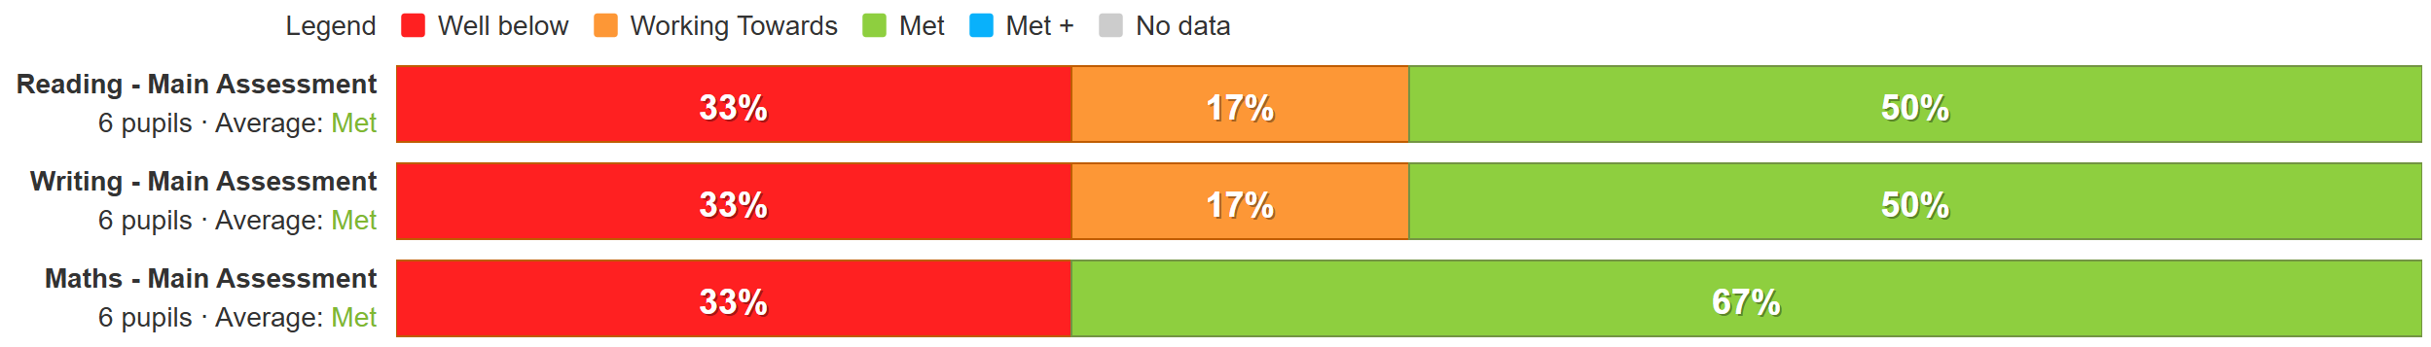

Overall progress
39 Pupils


