Spring 1- Year 4

 | Home Reading  5 times a week/as much as possible!  Please ensure reading books are brought in to school on a daily basis so we can read with pupils too!
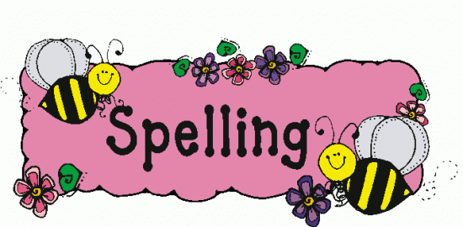 | Spellings  Words provided on a separate sheet. Spelling tests take place in class each week.
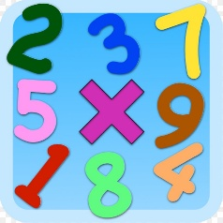 | Times Tables  By the end of the Year 4 children should know up to 12 x 12 and they are vital and will support children across the topics we will cover in maths. The Year 4 Multiplication Times Tables Check, which is statutory for all pupils, will take place in Summer Term.


Honesty:
Matthew 25:14-30 “Well done good and faithful servant, you have shown you can be faithful in small things, I will trust you with greater, come and join in your Master’s happiness.”

Mission and values:  Reflect on a time when you could have been honest. What did you choose to do and why? This could be written or drawn. | History:  In our first half term we will be learning about Ancient Greece. Research some Greek gods and what they are the god/goddess of. You could make a set of Top Trump cards!
Science:  This half-term’s topic is Animals Including Humans. We will be looking at the different types of teeth and what their functions are. Draw and label a diagram of our different types of teeth. | Art:  We will be researching and recreating artwork in the style of William Morris and his repeating patterns. Have a go at creating a repeating pattern in using leaves or flowers (this could be done outside using actual leaves!).

