EYFS Curriculum

The Early Years approach at St Mary Magdalene’s RC Primary School consists of the ethos that every child should be treated as an individual. We work together to ensure each child is respected, nurtured and reaches their full potential.
Intent
At St Mary Magdalene’s we want our Early Years children to be resilient, independent, imaginative learners with an eagerness to explore the world around them. We want our children to learn from the local area, be proud of where they live and where they are from. We want our children to leave the Early Years with memorable life and learning opportunities giving them the skills they need for later in life. The meaningful relationships they form with their peers and adults are important to ensure that children are encouraged to achieve their full potential and know that they are valued. We want children to know that their ambitions are limitless. We have designed a vocabulary rich curriculum aiming to expose the children to a wide range of books and inspiring authors. Staff aim to develop a children’s love of reading. We want our curriculum to be a child-centred inspirational learning process which supports play, exploration and supported risk taking. Following the child’s interests is important to develop the child’s curiosity for learning and we want the child to be active in their learning. We aim to develop confidence and self-esteem through child inspired, hands-on experiences in a setting where children feel safe, stimulated, and happy.
Implementation
Our Early Years setting offers a high quality, structured early years’ curriculum. This ensures our children make the best transition to school with strong foundations in early reading (phonics), writing and maths. The strong blend of educational approaches helps learners develop socially, emotionally, spiritually, physically and intellectually. The curriculum is defined by the Early Years Foundation Stage, which sets out seven areas of learning, and identifies what children should be able to do by the end of the EYFS (early learning goals). This is different to the National Curriculum which starts in Year 1.

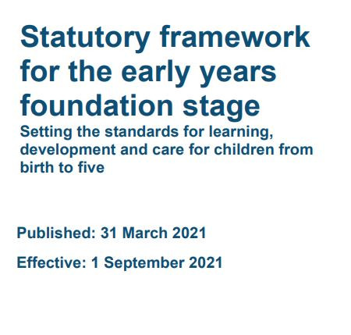

There are three Prime areas: Personal, Social and Emotional Development, Communication and Language and Physical Development. The four Specific Areas are Literacy, Mathematics, Understanding the World and Expressive Arts and Design.
Four guiding principles should shape practice in early years settings. These are:
• every child is a unique child, who is constantly learning and can be resilient, capable, confident and self-assured
• children learn to be strong and independent through positive relationships
• children learn and develop well in enabling environments with teaching and support from adults, who respond to their individual interests and needs and help them to build their learning over time. Children benefit from a strong partnership between practitioners and parents and/or carers.
• importance of learning and development. Children develop and learn at different rates.
At St Mary Magdalene’s a blended curriculum design is followed to ensure the statutory areas of the curriculum are secured alongside developing the whole child. This is to ensure the children leave ready for the next stage in their education having had a balance of child led and adult led learning opportunities.
Staff use the curriculum overview to plan activities around daily mathematics, literacy and phonics. We have a fidelity to the ‘Essential Letters and Sounds’ programme. The children are taught the sounds in phases and reading books are linked to the sounds they are learning; supplemented with additional reading materials. It aims to build children’s speaking and listening skills, as well as preparing children for learning to read by developing their phonic knowledge and skills.

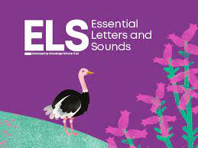

Maths – Mastering Number
Developing a strong grounding in number is essential so that all children develop the necessary building blocks to excel mathematically. Staff provide frequent and varied opportunities to build and apply this understanding by following NumberBlocks and resources such as using manipulatives. Children will develop a secure base of knowledge and vocabulary from which mastery of mathematics is built. In addition, it is important that the curriculum includes rich opportunities for children to develop their spatial reasoning skills across all areas of mathematics including shape, space and measures.
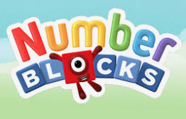

Other areas of the curriculum are planned for through continuous provision, play opportunities and adult led activities. These ensure pupils have the opportunities to show the characteristics of effective learning. Staff are encouraged to consider the individual needs, interests and development of each child in their care. They are encouraged to use this information to plan challenging and enjoyable experiences for each child in all areas of learning and development. Staff work in partnership with families and external support agencies to ensure all individual children’s needs are met.
Progression is planned for over the Early Years curriculum. Skills and knowledge are developed through repetition, sequencing and effective explanations to ensure learning is secured. For example, over the course of the Reception year the PSHE curriculum is planned for progression. The children start with learning to value themselves as an individual, progressing to expressing their emotions and understanding the feelings of others. In the last term the children are then guided to develop resilience in the face of challenge.
For example, over the course of the Reception year the Literacy curriculum is planned for progression using ‘The Write Stuff’ scheme. At the start of the year the children learn to recognise and correctly form the letters of the alphabet. Following this, the children begin to read and write simple words and captions. By the end of the year the children are reading short stories with confidence and understanding. In planning and guiding what children learn, staff reflect on the different rates at which children are developing and adjust their practice appropriately.

Characteristics of Effective Learning
Three characteristics of effective teaching and learning are:
• playing and exploring - children investigate and experience things, and ‘have a go’
• active learning - children concentrate and keep on trying if they encounter difficulties, and enjoy achievements
• creating and thinking critically - children have and develop their own ideas, make links between ideas, and develop strategies for doing things


