

Calculations Policy

2024-25

Contents
- Mathematical Terminology 1
- Calculation Policy Guidance… 2
- Addition: Mental Calculations 3
- Addition: Written Calculations (EYFS to Year 6) 4
- Subtraction: Mental Calculations 10
- Subtraction: Written Calculations (EYFS to Year 6) 11
- Multiplication: Mental Calculations 20
- Multiplication: Written Calculations (EYFS to Year 6) 21
- Division: Mental Calculations 31
- Division: Written Calculations (EYFS to Year 6) 32
- Representing Manipulatives 43
- Resources List 45

Mathematical Terminology
This calculation policy uses a range of mathematical terminology. They are terms that your child should be familiar with, depending on their Year Group. Also included are some standard terms used in class.
Addend- Any of the numbers that are added together. E.g. In 8 + 3 = 11, the 8 and the 3 are addends.
Array- Items (such as objects, numbers, etc.) arranged in rows and/or columns.
Bridging through ten- When performing additions or subtractions, counting through a tens boundary is called ‘bridging through ten’. It helps to count up to the boundary first, then through it. E.g. 18 + 4 will bridge through the boundary from 19 to 20, so we would count 18 + 2, then 20 + 2.
Column Addition- Addition by writing one number below the other and then adding one column at a time.
Counting back- As with counting on, but in subtraction.
Counting on- When performing a calculation, such as 8 + 3, start at 8 and count: 9, 10, 11. You can count on or back in tens or hundreds etc. as well as ones.
Commutative Law- The law that states that: a multiplication or addition can be made in any order to arrive at the same product or sum respectively. E.g. 8 + 5 + 2 = 15; 2 + 5 + 8 = 15 and 5 + 8 + 2 = 15. These calculations are said to demonstrate commutativity.
Decrease- Making something smaller (in size or quantity).
Difference- The result of a subtraction calculation. Dividend- A number that is to be divided in a calculation. Divisor- The number that the dividend is to be divided by.
Empty Number-Lines- A number-line without numbers. They are used when calculations involving numbers greater than 10. It would be impractical to calculate 87 – 23 with a printed number-line starting at 0. A line is drawn and the only numbers written on the line are the starting number (which depends on the method used) and the numbers arrived at whilst ‘jumping’ along it.
Estimate- To find a value that is close enough to the right answer, usually with some thought or calculation involved.
Exchanging- In multiplication, the act of giving or taking one thing in exchange for another e.g. tens.
Factors- Factors are whole numbers that can be multiplied to make a given whole number. E.g. 4 and 3 are factors of 12, so are 6 and 2.
Grid Method- A method for introducing written multiplications where the numbers involved are partitioned before multiplying. The products are recombined as they will obey Commutative Law.

Inverse Operations- The opposite of an operation. Inverse operations are used to find a missing value in a number sentence. The inverse of an addition is a subtraction and vice-versa. The inverse of a multiplication is a divide. However, the inverse of a divide calculation is not always a multiplication:
5 + 15 = 20 -> 20 – 5 = 15 (and vice-versa)
3 x 4 = 12 -> 12 ÷ 4 = 3 BUT… 12 ÷ 4 = 3 -> 3 x 12 is not 4! (You have to do 12 ÷ 3 to get 4).
Manipulative- any concrete objects that allow students to explore an idea in a hands-on approach.
Minuend- The first number in a subtraction. The number from which another number (the subtrahend) is to be subtracted. E.g. 8 – 3 = 5
Multiple- The result of multiplying a number by an integer (not by a fraction).
Multiplicand- The number that gets multiplied. E.g. 6 x 3 = 18
Number Sentence- An equation written in maths. Like in literacy, they must make sense. = means ‘the same as’; > means ‘more than’ and < means ‘less than’.
E.g. 6 + 8 = 20 WRONG or 6 + 8 > 20 WRONG
6 + 8 < 20 CORRECT because it makes sense.
Number Bonds- Number ‘facts’ that children will learn in KS1 and continue using to aid mental calculations. Number bonds can be to 10, 20, 100, 1000 and so on.
Operation- A procedure that produces a new value from two or more input values. + - x and ÷ are the four main arithmetic operations.
Partitioning- Splitting a number greater than 10 into its constituent thousands, hundreds, tens and ones. E.g. 4723 -> 4000 and 700 and 20 and 3.
Place Value- Place value determines the value of a digit depending on where it sits in the written number. E.g. 4562 -> The ‘5’ represents 500 in this case.
Prime Number- A number with only one factor. Every whole number greater than one is a product of prime numbers.
Product- The result of a multiplication calculation.
Quotient- The result of a division calculation. It is arrived at by counting groups of the divisor up to the total of the dividend.
Recombining- After partitioning and calculating, putting the numbers ‘back together’.
Remainder- When dividing, the remainder is how much of the divisor is needed to reach the dividend total when the quotient is not a whole number.
Subtrahend- The number that is to be subtracted. The second number in a subtraction. E.g. 8 – 3 = 5
Sum- The result of an addition calculation.

Calculation Policy Guidance
This policy supports both the Lancashire County Council Sequence of Learning for Reception and the Red Rose Maths Mastery Scheme used within Year 1 to 6. Progression within each area of calculation is in line with the programme of study in the 2014 National Curriculum. This calculation policy should be used to support children to develop a deep understanding of number and calculation. This policy has been designed to teach children through the use of concrete, pictorial and abstract representations.
- Concrete representation— a pupil is first introduced to an idea or skill by acting it out with real objects. This is a ‘hands on’ component using real objects and is a foundation for conceptual understanding.
- Pictorial representation – a pupil has sufficiently understood the ‘hands on’ experiences performed and can now relate them to representations, such as a diagram or picture of the problem.
- Abstract representation—a pupil is now capable of representing problems by using mathematical notation, for example 12 x 2 = 24.
It is important that conceptual understanding, supported by the use of representation, is secure for all procedures. Reinforcement is achieved by going back and forth between these representations.
Mathematics Mastery
At the centre of the mastery approach to the teaching of mathematics, is the belief that all children have the potential to succeed. They should have access to the same curriculum content and, rather than being extended with new learning, they should deepen their conceptual understanding by tackling challenging and varied problems. Similarly, with calculation strategies, children must not simply rote learn procedures but demonstrate their understanding of these procedures through the use of concrete materials and pictorial representations. This policy outlines the different calculation strategies that should be taught and used in Year 1 to Year 6 in line with the requirements of the 2014 Primary National Curriculum.
How to use the policy:
This mathematics policy is a guide for all staff in Leyland Methodist Schools and has been adapted from work by the NCETM. Teachers can use any teaching resources that they wish to use and the policy does not recommend one set of resources over another, rather that a variety of resources are used. For each of the four rules of number, different strategies are laid out, together with examples of what concrete materials can be used and how, along with suggested pictorial representations. The principle of the concrete- pictorial-abstract (CPA) approach [make it, draw it, write it] is for children to have a true understanding of a mathematical concept, they need to master all three phases within a year group’s scheme of work.

Addition: Mental Calculations
These are a selection of mental calculation strategies: Mental recall of number bonds
6 + 4 = 10 + 3 = 10
25 + 75 = 100 19 + = 20
Use near doubles
6 + 7 = double 6 + 1 = 13
Addition using partitioning and recombining
34 + 45 = (30 + 40) + (4 + 5) = 79
Counting on or back in repeated steps of 1, 10, 100, 1000
86 + 57 = 143 (by counting on in tens and then in ones) 460 - 300 = 160 (by counting back in hundreds)
Add the nearest multiple of 10, 100 and 1000 and adjust
24 + 19 = 24 + 20 – 1 = 43
458 + 71 = 458 + 70 + 1 = 529
Use the relationship between addition and subtraction
36 + 19 = 55 55 – 19 = 36
19 + 36 = 55 55 – 36 = 19
MANY MENTAL CALCULATION STRATEGIES WILL CONTINUE TO BE USED. THEY ARE NOT REPLACED BY WRITTEN METHODS.

Addition: Written Calculations

Addition- EYFS
Objectives | Concrete | Pictorial | Abstract
- Know that a group of things change in quantity when something is added.  - Find the total number of items in two groups by counting all of them.  - Say the number that is one more than a given number  - Find one more from a group of up to five objects, then ten objects  - In practical activities and discussion, beginning to use the vocabulary involved in adding  - Using quantities and objects, add two single digit numbers and count on to find the answer  - Solve problems including doubling | 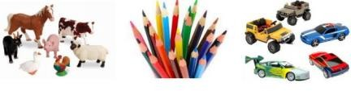  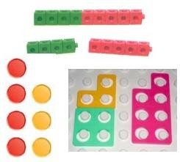  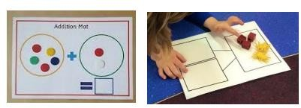  Use toys and general classroom resources for children to physically manipulate, group/regroup.  Use specific maths resources such as counters, snap cubes, Numicon etc.  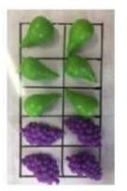  Use visual supports such as ten frames, part whole and addition mats, with the physical objects and resources that can be manipulated. | 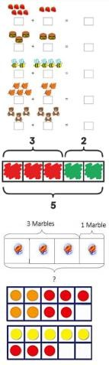  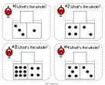  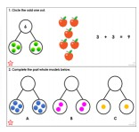  Two groups of pictures so children are able to count.  Bar model using visuals, pictures/icons or colours.  Use visual supports such as ten frames, part whole and addition mats with pictures/icons. | A focus on symbols and numbers to form a calculation.  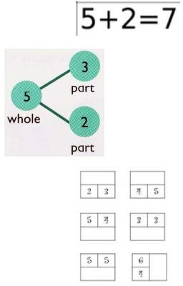  Note- No expectation for children to be able to record a number sentence/addition calculation.

Addition- Year 1
Vocabulary: add, more, plus, and, make, altogether, total, equal to, equals, double, most, count on, number line, balancing, part, whole
Objective and Strategy | Concrete | Pictorial | Abstract
Number bonds of 5, 6, 7, 8, 9 and 10  Combining two parts to make a whole: part- whole model | 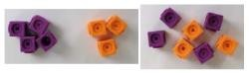  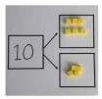  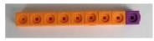  Use cubes to add numbers together as a group or in a bar. (Some children still need to use real objects)  Use the part-whole model. | 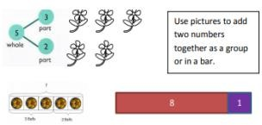  The Bar Model will be continued from EYFS as a method to support problem solving involving addition, continuing with the concrete representations and moving onto using pictorial representations of objects. Some children will also move onto the abstract. | 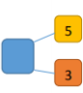  Using the part- whole model (left) to move into the abstract.  4 + 3 + 7  10 = 6 + 4
Counting  Start with a larger number and count on using a bead string/number line |   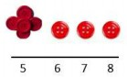  Start with the larger number on the bead string and then count on to the smaller number 1 by 1 to find the answer. | Use a number line to count on in ones.  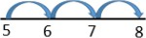 | 5 + 3 = 8

Addition- Year 1
Vocabulary: add, more, plus, and, make, altogether, total, equal to, equals, double, most, count on, number line, balancing, part, whole
Objective and Strategy | Concrete | Pictorial | Abstract
Represent and use number bonds and related subtraction facts within 20 | 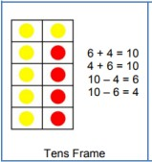  (Some children may need to initially use real objects then move onto the representation, egg boxes may also be used to support this) | 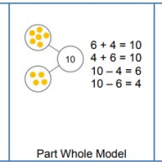 | 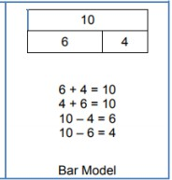  Bar model and part-whole to be used alongside abstract.
Addition and subtraction of one-digit and two- digit numbers to 20 including 0 |  | 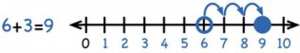  Start at the larger number on the number line and count on in ones. | 5 + 12 = 17  17 = 12 + 5
Regrouping to make 10.  The ‘Make 10’ strategy | 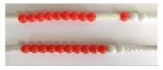  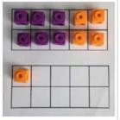  Start with the bigger number and use the smaller number to make 10.  Use ten frames. | Use pictures or a number line.  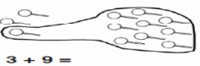  Regroup or partition the smaller number using the part-whole model to make 10.  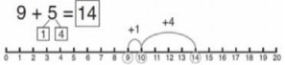 | 7 + 4= 11  If I am at seven, how many more do I need to make 10. How many more do I add on now?

Addition- Year 2
Vocabulary: add, more, plus, and, make, altogether, total, equal to, equals, double, most, count on, number line, sum, tens, units, partition, addition, column, tens boundary
Objective and Strategy | Concrete | Pictorial | Abstract
Adding 3 1-digit numbers | 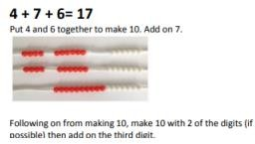 | 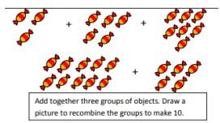 | 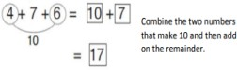
Adding a 2-digit number and ones | 17 + 5 = 22  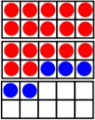  Use ten frame to make  ‘magic ten’  Children explore the pattern: 17 + 5 = 22 27 + 5 = 32 | 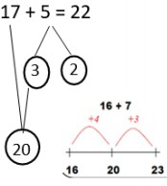  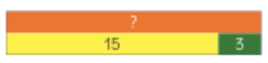  Using the part- whole, number line and bar model. | 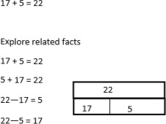
Adding a 2-digit number and multiples of 10 | 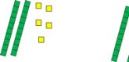  25 + 10 = 35  Explore that the ones digit does not change. | 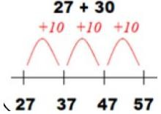  Base 10 may be used above the number line initially.  The calculation will be shown alongside the number line to see the connection. | 27 + 10 = 37  27 + 20 = 47  27 + □ = 57

Addition- Year 2
Vocabulary: add, more, plus, and, make, altogether, total, equal to, equals, double, most, count on, number line, sum, tens, units, partition, addition, column, tens boundary
Objective and Strategy | Concrete | Pictorial | Abstract
Column method without regrouping | Add together the ones first, then add the tens. Use the Base 10 blocks first before moving onto place value counters.  24 + 15 = 44 + 15 =  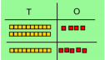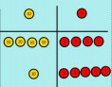 | After physically using the base 10 blocks and place value counters, children can draw the counters to help them to solve additions.  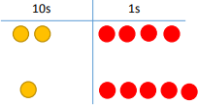 | 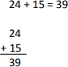
Column method with regrouping | Make both numbers on a place value grid.  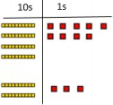  Add up the ones and exchange 10 ones for 1 ten.  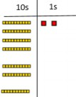 | Using place value counters, children can draw the counters to help them to solve additions.  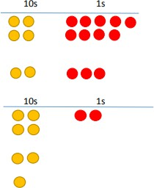 | Partitioning:  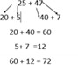  Recording addition in columns supports place value and prepares for formal written methods with larger numbers. Toward the end of the year, children move to more formal recording using partitioning method:  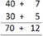

Addition- Year 3
Vocabulary: addition, add, more, and make, sum, total, altogether, double, near double, half, halve, tens boundary, hundreds boundary
Objective and Strategy | Concrete | Pictorial | Abstract
Add and subtract numbers with up to 3-digits, using formal written methods of columnar addition  Column addition (no regrouping) | 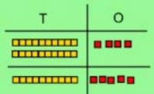  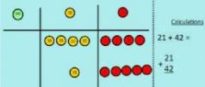  Using manipulatives (dienes, numicon, counters), children are to line up hundreds, tens and ones.  Children should be secure with using PV counters before moving onto pictorial. | 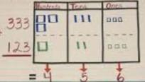  Children are to draw, in a PV frame, the manipulatives, that they are using.  Secure knowledge of representation with the PV columns. | 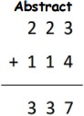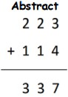  Children to move onto recording more formally. Some children may need to use the expanded method (see below).
Column addition (with regrouping) | 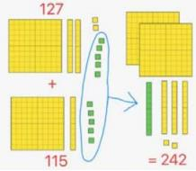  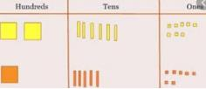  Exchange ten ones for a ten. Model using dienes, numicon and place value counters. | 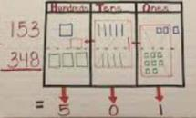  Children can draw a representation of the grid to further support their understanding, carrying the ten underneath the line. | 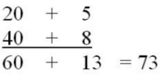  Children are to begin with the abstract: expanded form. For those children that are confident after AFL, the below method should be used.
Addition- Year 3
Children should
be secure with using PV counters before moving onto pictorial.
Exchange ten
ones for a ten. Model using dienes, numicon and place value counters.

Addition- Year 4
Vocabulary: addition, add, more, and make, sum, total, altogether, double, near double, half, halve, tens boundary, hundreds boundary, decimal, decimal point
Objective and Strategy | Concrete | Pictorial | Abstract
Using formal written methods of columnar addition where appropriate  Add numbers with up to 4 digits (with exchange) | Children continue to use dienes or place value counters to add, exchanging ten ones for a ten, ten tens for a hundred and ten hundreds for a thousand.  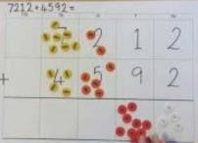 | 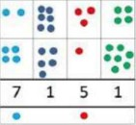  Children can draw a pictorial representation of the columns and place value counters to further support their learning and understanding. | 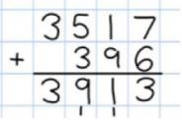  Continue from previous work to carry hundreds as well as tens.
Add decimals with 2 decimals places, including money | 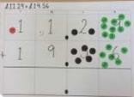  Introduce decimal place value counters and model exchange for addition. | 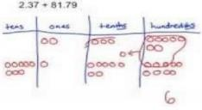 | 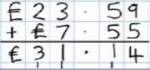  As the children move on, introduce decimals with the same number of decimal places and different money can be used here.

Addition- Years 5 and 6
Vocabulary: addition, add, more, and make, sum, total, altogether, double, near double, half, halve, tens boundary, hundreds boundary, decimal, decimal point
Objective and Strategy | Concrete | Pictorial | Abstract
Add numbers with more than 4 digits | See Year 4 | See Year 4 | 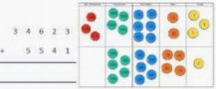  Children should have abstract supported by a pictorial or concrete if needed.
Add decimals with 2 decimals places, including money | See Year 4 | See Year 4 | 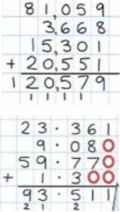  Insert zeros for place holders.

Subtraction: Mental Calculations

These are a selection of mental calculation strategies:

Mental recall of addition and subtraction facts
10 – 6 = 4 17 = 11
20 - 17 = 3 10 - = 2

Find a small difference by counting up
82 – 79 = 3

Counting on or back in repeated steps of 1, 10, 100, 1000 86 - 52 = 34 (by counting back in tens and then in ones) 460 - 300 = 160 (by counting back in hundreds)
Subtract the nearest multiple of 10, 100 and 1000 and adjust
24 - 19 = 24 – 20 + 1 = 5
458 - 71 = 458 - 70 - 1 = 387
Use the relationship between addition and subtraction
36 + 19 = 55 55 – 19 = 36
19 + 36 = 55 55 – 36 = 19

MANY MENTAL CALCULATION STRATEGIES WILL CONTINUE TO BE USED. THEY ARE NOT REPLACED BY WRITTEN METHODS.

Subtraction: Written Calculations

Subtraction- EYFS
Objectives | Concrete | Pictorial | Abstract
- Know that a group of things change in quantity when something is taken away.  - Find one less from a group of five objects, then ten objects.  - In practical activities and discussion, begin to use the vocabulary involved in subtracting.  - Using quantities and objects, subtract two single digit numbers and count back to find the answer. | Use toys and general classroom resources for children to physically manipulate, group/regroup.  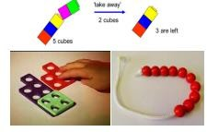  Use specific maths resources such as bead strings, snap cubes, Numicon etc.  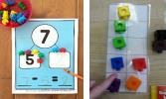  Use visual supports such as ten frames, part whole and addition mats, with the physical objects and resources that can be manipulated. | 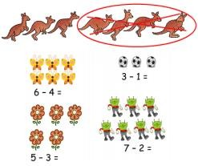  A group of pictures for children to cross out or cover quantities to support subtraction.  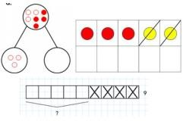  Use visual supports such as ten frames, part whole and addition mats with pictures/icons. | A focus on symbols and numbers to form a calculation.  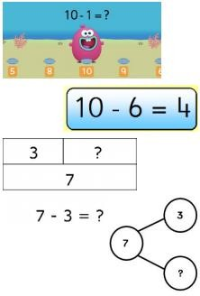  Note- No expectation for children to be able to record a number sentence/subtraction calculation.

Subtraction- Year 1
Vocabulary: equal to, take, take-away, less, minus, subtract, leaves, distance between, how many more, how many fewer/less than, most, least count back, how many left, how much less is
Objective and Strategy | Concrete | Pictorial | Abstract
Subtract one-digit and two-digit numbers to 20, including 0.  Taking away ones. | Use physical objects, counters, cubes etc. to show how objects can be taken away.  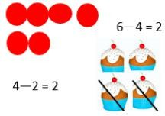 | Cross out drawn objects to show what has been taken away.  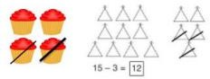 | 7 - 4 = 3  16 - 9 = 7
Counting back  Start with a larger number and count back using a bead string/number line. | Make the larger number in your subtraction. Move the beads along as your bead string as you count backwords in ones.  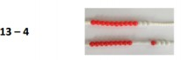  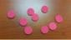  Use counters and move them away from the group as you take away counting backwards as you go. | 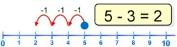  Count back on a number line or track. Start at the bigger number and count back to the smaller number showing the jumps on the number line. | Put 13 in your head, count back 4. What number are you at? (Use your fingers to help you).

Subtraction- Year 1
Vocabulary: equal to, take, take-away, less, minus, subtract, leaves, distance between, how many more, how many fewer/less than, most, least count back, how many left, how much less is
Objective and Strategy | Concrete | Pictorial | Abstract
Find the difference | 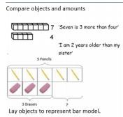 | 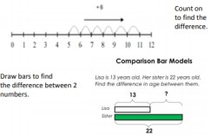 | Hannah has 12 sweets and her sister has 5. How many more does Hannah have than her sister?
Represent and use number bonds and related subtraction facts within 20  Part- whole model | Link to addition. Use part- whole model to model the inverse.  If 10 is the whole and 6 is one of the parts, what is  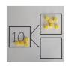  10 – 6 = 4 the other part? | 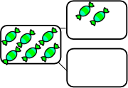  Use a pictorial representation of objects to show the part-whole model. | 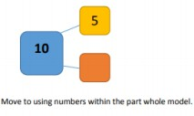
Make 10 | 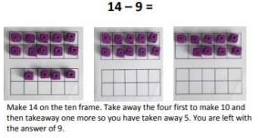 | 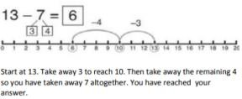 | 16 – 8=  How many do we take off to reach the next 10? How many do we have left to take off?

Subtraction- Year 2
Vocabulary: equal to, take, take-away, less, minus, subtract, leaves, distance between, how many more, how many fewer/less than, most, least count back,
how many left, how much less is…difference, count on, strategy, partition, tens units
Objective and Strategy | Concrete | Pictorial | Abstract
Subtract a two-digit number and ones, a two-digit number and tens, two two-digit numbers.  Partitioning to subtract without regrouping: ‘Friendly numbers’ | 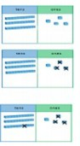  34 - 13 = 21  Use dienes to show how to partition the number when subtracting without regrouping.  This calculation will be shown alongside the manipulative used.  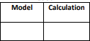 | 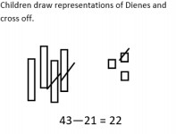 | 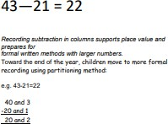
Make 10 strategy | 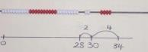  34—28  Use a bead bar or bead strings to model counting to next ten and the rest | 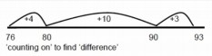  Use a number line to count on to next ten and then the rest. | 93 – 76 = 17

Subtraction- Year 3
Vocabulary: equal to, take, take-away, less, minus, subtract, leaves, distance between, how many more, how many fewer/less than, most, least count back,
how many left, how much less is…difference, count on, strategy, partition, tens units
Objective and Strategy | Concrete | Pictorial | Abstract
Subtract numbers with up to three-digits, using formal written methods of columnar subtraction  Column subtraction (without exchanging) | 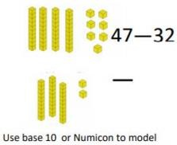  This calculation will be shown alongside the model chosen to see the calculation. | Children are to be secure with use of PV counters before moving onto abstract.  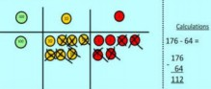 | Children should begin with the expanded form. Moving onto a more formal way as below.  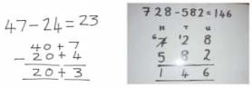
Subtract numbers with up to three-digits, using formal written methods of columnar subtraction  Column subtraction (with exchanging) | Begin with base 10 or Numicon. Move to place value counters, modelling the exchange of a ten into ten ones. Use the phrase ‘take and make’ for exchange.  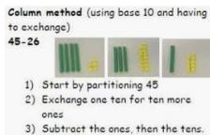 | 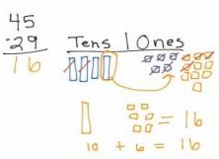  When confident, children can find their own way to record the exchange/regrouping. | Children should begin with the expanded form. Moving onto a more formal way as below (bottom picture).  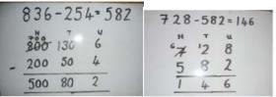

Subtraction- Year 3
Vocabulary: equal to, take, take-away, less, minus, subtract, leaves, distance between, how many more, how many fewer/less than, most, least count back,
how many left, how much less is…difference, count on, strategy, partition, tens units
Objective and Strategy | Concrete | Pictorial | Abstract
Subtract numbers with up to three-digits, using formal written methods of columnar subtraction  Column subtraction (with exchanging)  (continued) | 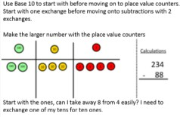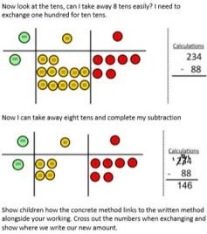

Subtraction- Year 4
Vocabulary: equal to, take, take-away, less, minus, subtract, leaves, distance between, how many more, how many fewer/less than, most, least count back,
how many left, how much less is…difference, count on, strategy, partition, tens units
Objective and Strategy | Concrete | Pictorial | Abstract
Subtract numbers with up to 4 digits using the formal written methods appropriate of columnar subtraction where appropriate.  Year 4 subtraction with up to 4 digits. | Model process of exchange using Numicon, base ten and then move to place value counters.  Use the phrase ‘take and make’ for exchange- see Y3.  The calculation will be shown alongside the model chosen to see the connection. | Children to draw place value counters and show their exchange—see Y3.  The calculation will be shown alongside the model chosen to see the connection. | 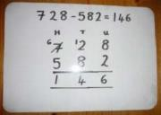  This will lead to an understanding of subtracting any number including decimals.
Introduce decimal subtraction through context of money. | Children to be encouraged to use counters to represent numbers and take counters away to subtract.  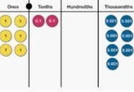 | 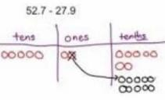  When confident, children can find their own way to record the exchange/regrouping. | 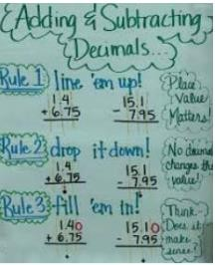

Subtraction- Year 5 and 6
Vocabulary: equal to, take, take-away, less, minus, subtract, leaves, distance between, how many more, how many fewer/less than, most, least count back,
how many left, how much less is…difference, count on, strategy, partition, tens units
Objective and Strategy | Concrete | Pictorial | Abstract
Subtract with at least 4 digits, including money and measures.  Subtract with increasingly large and more complex numbers and decimal values (up to 3 decimal place). | See Year 4 | See Year 4 | 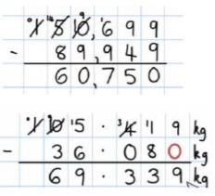

Multiplication: Mental Calculations
These are a selection of mental calculation strategies:

Doubling and halving
Applying the knowledge of doubles and halves to known facts. e.g. 8 x 4 is double 4 x 4

Using multiplication facts
Tables should be taught every day from Year 1 onwards, either as part of the mental oral starter, games or other times as appropriate within the day.
Year 1: 2, 5 and 10 times table
Year 2: 2, 3, 5 and 10 times table
Year 3: 2, 3, 4, 5, 6 and 10 times table
Year 4 Derive and recall all multiplication facts up to 12 x 12
Years 5 & 6 Derive and recall quickly all multiplication facts up to 12 x 12
Using and applying multiplication facts
Children should be able to utilise their tables knowledge to derive other facts.
E.g. If I know 3 x 7 = 21, what else do I know?
30 x 7 = 210, 300 x 7 = 2100, 3000 x 7 = 21 000, 0.3 x 7 = 2.1 etc.

Use closely related facts already known
13 x 11 = (13 x 10) + (13 x 1) = 130 + 13 = 143

Multiplying by 10 or 100
Knowing that the effect of multiplying by 10 is a shift in the digits one place to the left and that the effect of multiplying by 100 is two places to the left.

Partitioning
23 x 4 = (20 x 4) + (3 x 4) = 80 + 12 = 92

Use of factors
8 x 12 = 8 x 4 x 3

MANY MENTAL CALCULATION STRATEGIES WILL CONTINUE TO BE USED. THEY ARE NOT REPLACED BY WRITTEN METHODS.

Multiplication: Written Calculations

Multiplication- EYFS
Objectives | Concrete | Pictorial | Abstract
- Solve problems including doubling. | 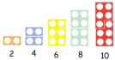  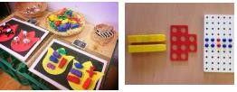  Counting and other Maths resources for children to make 2 equal groups.  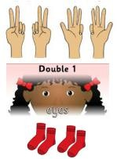  Physical and real life examples that encourage children to see concept of doubling as adding two equal groups. | 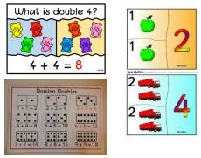  Pictures and icons that encourage children to see concept of doubling as adding two equal groups. | 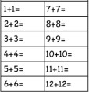  Adding calculations to model adding two equal groups.

Multiplication- Year 1
Vocabulary: groups of, lots of, times, array, altogether, multiply
Objective and Strategy | Concrete | Pictorial | Abstract
Doubling | 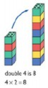  Use practical activities using manipulatives including cubes and Numicon to demonstrate doubling.  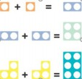 | 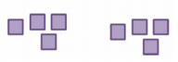  Draw pictures to show how to double numbers. | 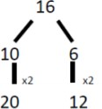  Partition each number and then double each part before recombining it back together.
Counting in multiples | 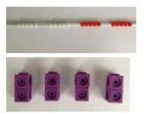  Count in multiples supported by concrete objects in equal groups. | 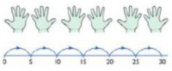  Use a number line or pictures to continue support in counting multiples. | Count in multiples of a number aloud.  Write sequences with multiples of numbers.  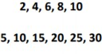
Repeated addition | Use different objects to add equal groups.  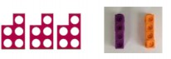 | 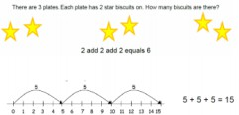 | Write addition sentences to describe objects and pictures.  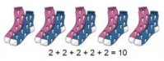

Multiplication- Year 1
Vocabulary: groups of, lots of, times, array, altogether, multiply
Objective and Strategy | Concrete | Pictorial | Abstract
Repeated addition (continued) |  | Use pictorial including number lines to solve problems.  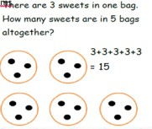
Understanding arrays | Use objects laid out in arrays to find the answers to 2 lots of 5, 3 lots of 2 etc.  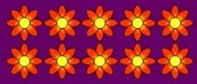 | 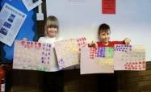  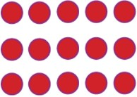 | 3 x 2 = 6  2 x 5 = 10

Multiplication- Year 2
Vocabulary: Groups of, lots of, times, array, altogether, multiply, multiplied by, repeated addition, sets of, equal groups, times as big as, commutative.
Objective and Strategy | Concrete | Pictorial | Abstract
Counting in multiples of 2, 3, 4, 5, 10 from 0 (repeated addition) | Count the groups as children are skip counting. Children may use their fingers as they are skip counting. Use bar models.  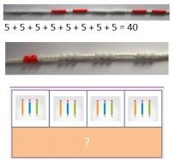 | Number lines, counting sticks and bar models should be use to show representation of counting in multiples.  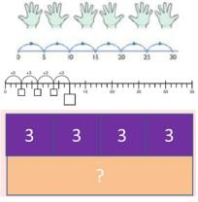 | Count in multiples of a number aloud.  Write sequences with multiples of numbers. 0, 2, 4, 6, 8, 10  0, 3, 6, 9, 12, 15  0, 5, 10, 15, 20, 25, 30  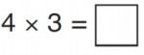
Multiplication is commutative | Create arrays using counters, cubes and Numicon.  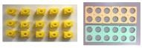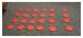  Pupils should understand that an array can represent different equations and that, as multiplication is commutative, the order of the multiplication does not affect the answer. | Use representations of arrays to show different calculations and explore commutatively.  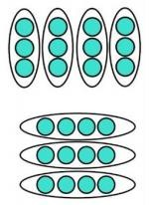 | 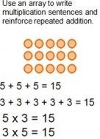  12 = 3 x 4  12 = 4 x 3

Multiplication- Year 2
Multiplication- Year 2
Vocabulary: Groups of, lots of, times, array, altogether, multiply, multiplied by, repeated addition, sets of, equal groups, times as big as, commutative.
Objective and Strategy | Concrete | Pictorial | Abstract
Using the Inverse | 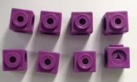 | 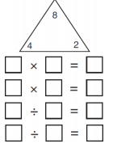 | Show all 8 related fact family sentences:
This should be taught alongside division, so |  |  | 2 x 4 = 8  4 x 2 = 8  8 ÷ 2 = 4
pupils learn how they |  |  | 8 ÷ 4 = 2
work alongside each |  |  | 8 = 2 x 4
other. |  |  | 8 = 4 x 2  2 = 8 ÷ 4
 |  |  | 4 = 8 ÷ 2

Multiplication- Year 3
Vocabulary: Groups of, lots of, times, array, altogether, multiply, multiplied by, repeated addition, sets of, equal groups, times as big as, commutative, product, multiples of, scale up
Objective and Strategy | Concrete | Pictorial | Abstract
Multiplying two-digit number by a one-digit number  Grid method progressing to the formal method  Solving problems including missing number problems, integer scaling problems | 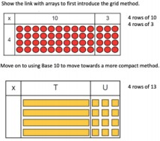  Move on to place value counters to show how we are finding groups of a number.  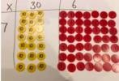  Add up each column, starting with the ones making any exchanges needed.  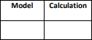  The calculation will be shown alongside the model to see the  connection. | Children can represent their work with place value counters in a way that they understand.  They can draw the counters using colours to show different amounts or just use the circles in the different columns to show their thinking as shown below:  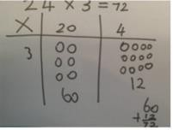  Bar model are used to explore missing numbers.  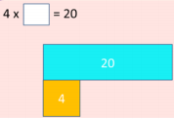 | Start with multiplying by one digit numbers and showing the clear addition alongside the grid.  TO X O  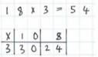  Children to add up each column to find the answer.

Multiplication- Year 4
Vocabulary: Groups of, lots of, times, array, altogether, multiply, multiplied by, repeated addition, sets of, equal groups, times as big as, commutative, product, multiples of, scale up, inverse, derive
Objective and Strategy | Concrete | Pictorial | Abstract
Multiply two-digit and three-digit numbers by a one-digit number using formal written layout  Grid method recap from year 3 for 2 digits  x 1 digit  Multiplying numbers by 1 digit (year 4 expectation) | 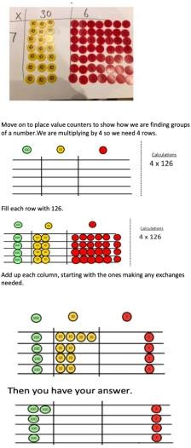 | Children can represent their work with place value counters in a way that they understand.  They can draw the counters using colours to show different amounts or just use the circles in the different columns to show their thinking as shown below: | HTO X O  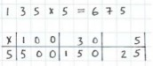  Children to add up each column to find the answer.

Multiplication- Year 4
Vocabulary: Groups of, lots of, times, array, altogether, multiply, multiplied by, repeated addition, sets of, equal groups, times as big as, commutative, product, multiples of, scale up, inverse, derive
Objective and Strategy | Concrete | Pictorial | Abstract
Column Multiplication | Children can continue to be supported by place value counters at the stage of multiplication. This initially done where there is no regrouping.  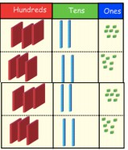  E.g. 321 x 2 = 642  It is important at this stage that they always multiply the ones first.  The corresponding long multiplication is modelled alongside: | The grid method may be used to show how this relates to a formal written method:  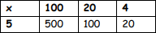  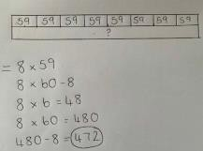  Bar modelling and number line can support learners when solving problems with multiplication alongside the formal written methods. | 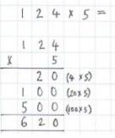  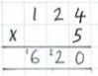  This may lead to a compact method.

Multiplication- Year 5
Vocabulary: Groups of, lots of, times, array, altogether, multiply, multiplied by, repeated addition, sets of, equal groups, times as big as, commutative, product, multiples of, scale up, inverse, derive, factor pairs, composite numbers, prime number, factors, squared, cubed
Objective and Strategy | Concrete | Pictorial | Abstract
Multiply numbers up | See Year 4 | 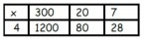 | 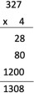  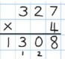  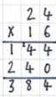  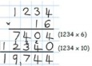  This may lead to a compact method.
to 4-digits by a one-
digit number using the
format written
method, including long
multiplication for 2-
digit numbers
Column multiplication
for 3 and 4 digits x 1
digit
Column multiplication (long multiplication) | Manipulatives may still be used with the corresponding long multiplication modelled alongside. | Moving forward, multiply by a 2-digit number showing the different rows within the grid method. | 24 x 6 on the first row.
 | 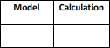 | 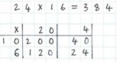 | (6 x 4 = 24, carrying the 2 for  the 20, then 6 x 2)  24 x 10 on the second row. Show multiplying by 10 by putting zero in the units first.

Multiplication- Year 6
Vocabulary: Groups of, lots of, times, array, altogether, multiply, multiplied by, repeated addition, sets of, equal groups, times as big as, commutative, product, multiples of, scale up, inverse, derive, factor pairs, composite numbers, prime number, factors, squared, cubed
Objective and Strategy | Concrete | Pictorial | Abstract
Multiply multi-digit numbers up to 4 digits by a 2-digit number using the formal written method of long multiplication. | See Year 5 | See Year 5 | See Year 5
Multiply decimal up to 2 decimal place by a single digit |  |  | Remind children that the single digit belongs in the ones column. Line up the decimal points in the question and the answer.  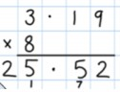

Division: Mental Calculations

These are a selection of mental calculation strategies:

Doubling and halving
Knowing that halving is dividing by 2.

Deriving and recalling division facts
Tables should be taught every day from Year 1 onwards, either as part of the mental oral starter, games or other times as appropriate within the day.

Year 1: 2, 5 and 10 times table
Year 2: 2, 3, 5 and 10 times table
Year 3: 2, 3, 4, 5, 6 and 10 times table
Year 4 Derive and recall all multiplication facts up to 12 x 12
Years 5 & 6 Derive and recall quickly all multiplication facts up to 12 x 12

Using and applying division facts
Children should be able to utilise their tables knowledge to derive other facts.
e.g. If I know 3 x 7 = 21, what else do I know?
30 x 7 = 210, 300 x 7 = 2100, 3000 x 7 = 21 000, 0.3 x 7 = 2.1 etc.

Dividing by 10 or 100
Knowing that the effect of dividing by 10 is a shift in the digits one place to the right. Knowing that the effect of dividing by 100 is a shift in the digits two places to the right.
Use of factors
378 ÷ 21 378 ÷ 3 = 126 378 ÷ 21 = 18
126 ÷ 7 = 18

Use related facts
Given that 1.4 x 1.1 = 1.54
What is 1.54 ÷ 1.4, or 1.54 ÷ 1.1?

MANY MENTAL CALCULATION STRATEGIES WILL CONTINUE TO BE USED. THEY ARE NOT REPLACED BY WRITTEN METHODS

Division: Written Calculations

Division- EYFS
Objectives | Concrete | Pictorial | Abstract
-Solve problems including halving and sharing.  - Halving a whole,  halving a quantity of objects.  - Sharing a quantity of objects. | 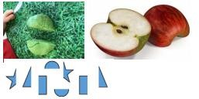  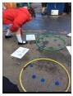  Children have the opportunity to physically cut objects, food or shapes in half.  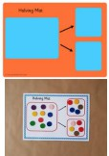  Counting and other maths resources for children to share into two equal groups.  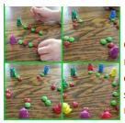  Use visual supports such as halving mats and part whole, with the physical objects and resources that can be manipulated.  Counting and other maths resources for children to explore sharing between 3 or more. | 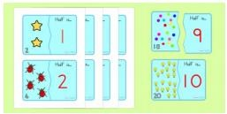  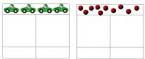  Pictures and icons that encourage children to see concept of halving in relation to addition and subtraction knowledge. i.e. knowing that 4 is made up of 2 groups of 2, so half of 4 is 2.  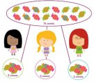  Bar model with pictures or icons to support understanding of finding 2 equal parts of a number, to further understand how two halves make a whole.  Pictures for children to create and visualise 3 or more equal groups.

Division- Year 1
Vocabulary: share, share equally, one each, two each…, group, groups of, lots of, array
Objective and Strategy | Concrete | Pictorial | Abstract
Division as sharing (sharing objects into groups) | 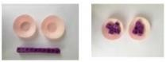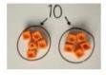  I have 10 cubes; can you share them equally into 2 groups? | 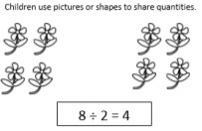  Children use bar modelling to show and support understanding.  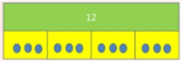  12 ÷ 4 = 3 | 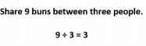

Division- Year 2
Vocabulary: share, share equally, one each, two each…, group, groups of, lots of, array, divide, divided by, divided into, division, grouping, number line, left, left over
Objective and Strategy | Concrete | Pictorial | Abstract
Division as grouping | Divide quantities into equal groups.  Use cubes, counters, objects or place value counters to aid understanding.  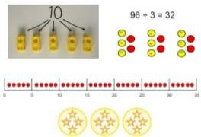 | Use a number line to show jumps in groups. The number of jumps equal the number of groups.  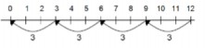  Think of the bar as a whole. Split it into the number of groups you are dividing by and work out how many would be within each group.  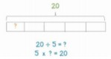 | 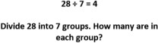

Division- Year 3
Vocabulary: share, share equally, one each, two each…, group, groups of, lots of, array, divide, divided by, divided into, division, grouping, number line, left, left over, product
Objective and Strategy | Concrete | Pictorial | Abstract
Division as grouping | Use cubes, counters, objects or place value counters to aid understanding.  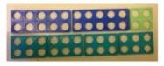  24 divided into groups of 6 = 4  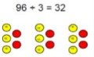 | Continue to use bar modelling to aid solving division problems.  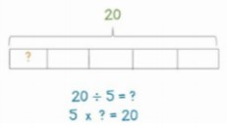 | 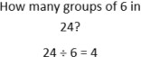
Division with arrays | 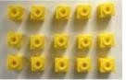  Link division to multiplication by creating an array and thinking about the number sentences that can be created.  E.g. 15 ÷ 3 = 5 5 x 3 = 15  15 ÷ 5 = 3 3 x 5 = 15 | Draw an array and use lines to split the array into groups to make multiplication and division sentences.  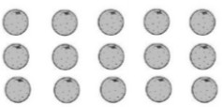 | Find the inverse of multiplication and division sentences by creating eight linking number sentences.  7 x 4 = 28  4 x 7 = 28  28 ÷ 7 = 4  28 ÷ 4 = 7  28 = 7 x 4  28 = 4 x 7  4 = 28 ÷ 7  7 = 28 ÷ 4

Division- Year 3
Vocabulary: share, share equally, one each, two each…, group, groups of, lots of, array, divide, divided by, divided into, division, grouping, number line, left, left over, product
Objective and Strategy | Concrete | Pictorial | Abstract
Divide 2-digit numbers by a 1-digit number by partitioning into tens and ones using a place value grid | 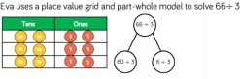 | See part-whole model
Divide numbers that involve exchanging between the tens and ones. The answers do not have remainders | 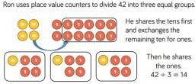 | 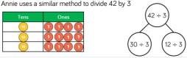  Children may use pictorial representation for the place value counters, alongside the part-whole model.  Children use their times-tables to partition the number into multiples of the divisor. | 96 ÷ 8  96 ÷ 4  96 ÷ 3  96 ÷ 6  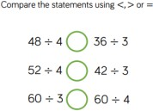

Division- Year 3
Vocabulary: share, share equally, one each, two each…, group, groups of, lots of, array, divide, divided by, divided into, division, grouping, number line, left, left over, product
Objective and Strategy | Concrete | Pictorial | Abstract
Division with a remainder | 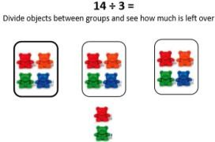  Moving on to:  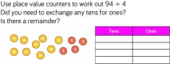 | Jump forward in equal jumps on a number line then see how many more you need to jump to find a remainder.  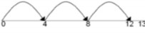  Draw dots and group them to divide an amount and clearly shows a remainder.  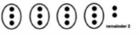  Use bar models to show division with remainders.  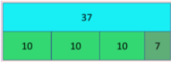 | Complete written division and show the remainder using r.  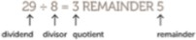

Division- Year 4
Vocabulary: share, share equally, one each, two each…, group, groups of, lots of, array, divide, divided by, divided into, division, grouping, number line, left, left over, product, division facts, inverse, derive
Objective and Strategy | Concrete | Pictorial | Abstract
Divide up to 3-digit numbers by 1-digit  Short Division | 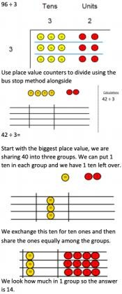 | Students can continue to use drawn diagrams with dots or circles to help them divide numbers into equal groups.  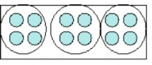  Encourage them to move towards counting in multiples to divide more efficiently. | Begin with divisions that divide equally with no remainder.  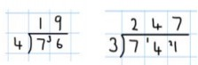  Children should be aware that a 0 is used to keep place value, if the number is not divisible.  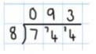  Move onto divisions with a remainder.  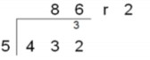

Division- Year 5
Vocabulary: share, share equally, one each, two each…, group, groups of, lots of, array, divide, divided by, divided into, division, grouping, number line, left, left over, product, division facts, inverse, derive, formal written method
Objective and Strategy | Concrete | Pictorial | Abstract
Divide at least 4-digit numbers by 1-digit.  Interpret remainders appropriately for the context.  Short Division | See Year 4 | Students can continue to use drawn diagrams with dots or circles to help them divide numbers into equal groups.  Encourage them to move towards counting in multiples to divide more efficiently. | 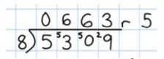  Finally move into decimal places to divide the total accurately.  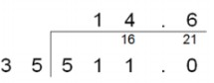

Division- Year 6
Vocabulary: share, share equally, one each, two each…, group, groups of, lots of, array, divide, divided by, divided into, division, grouping, number line, left, left over, product, division facts, inverse, derive, formal written method
Objective and Strategy | Abstract
Long Division | 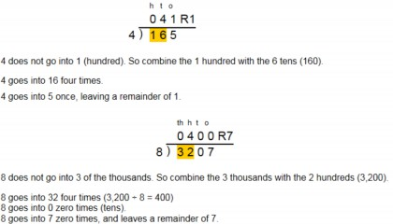  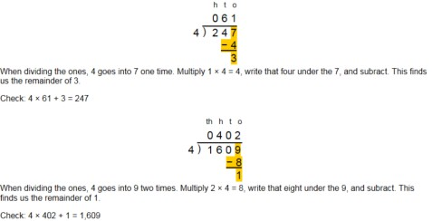  Step 1- A remainder in the ones

Division- Year 6
Vocabulary: share, share equally, one each, two each…, group, groups of, lots of, array, divide, divided by, divided into, division, grouping, number line, left, left over, product, division facts, inverse, derive, formal written method
Objective and Strategy | Abstract
Long Division | Step 1- A remainder in the tens  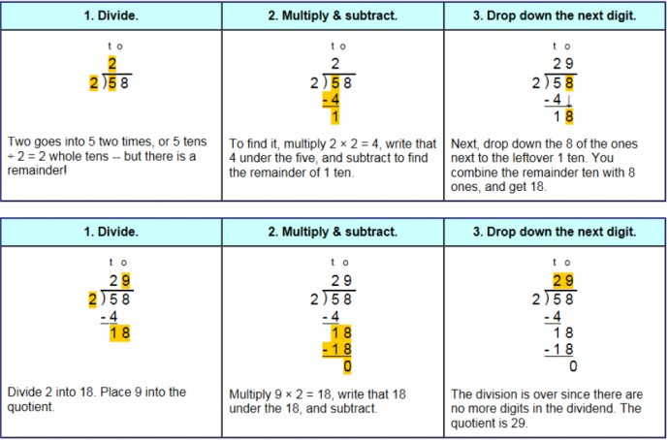

Division- Year 6
Vocabulary: share, share equally, one each, two each…, group, groups of, lots of, array, divide, divided by, divided into, division, grouping, number line, left, left over, product, division facts, inverse, derive, formal written method
Objective and Strategy | Abstract
Long Division | 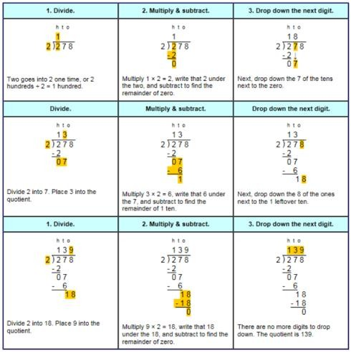  Step 1- A remainder in any of the place values

Representing Manipulatives

Dienes/Base 10
Children can record calculations using their own drawings of Base 10 equipment (as slanted lines for the tens rods and dots for the ones blocks). Year 2 Examples:
34 + 23 =

With exchange: 28 + 36 =

so 28 + 36 = 64

exchanged 10

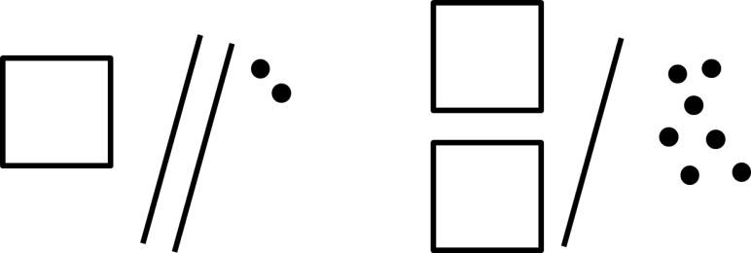
It is important that children circle the remaining tens and units/ones after exchange to identify the amount remaining.
will become
This method can also be used with adding three digit numbers, e.g. 122 + 217 using a square as the representation of 100 (a cube would be used for a representation of 1000).

Place Value Counters
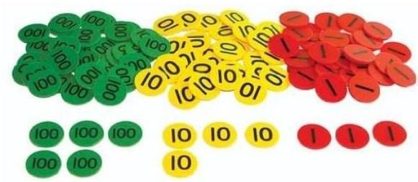
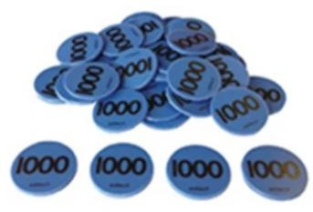
Children can record calculations using their drawings of place value counters as coloured dots (see below): Ones = red
Tens = yellow Hundreds = green Thousands = blue

Examples:
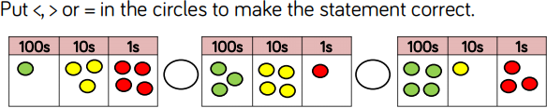
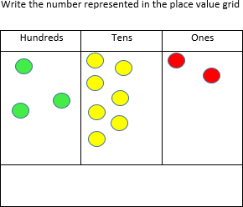

Resources required to support the CPA approach (depending on the year group) for this calculation policy:

- Ten frames
- Straws/pipe cleaners
- Bead strings (to 20 and 100)
- Base 10/Dienes
- Place value grids
- Number lines
- Two-coloured counters
- Part-whole templates
- Place value counters (KS2)
- Multi-link cubes

